**Final Assignment**

**Programming fundamentals**

**20st December, 2020 11:59pm**

**Weightage 5.**

**Note.**

* **Please avoid plagiarism.**
* **Contact me on email in case of any query.**
* **No late submissions would be accepted.**
* **Submit assignment on google classroom and note google classroom also checks plagiarism, so be careful.**
* **Only 25 to 30% plagiarism is acceptable.**

Q1. **Weightage (3)**Provide the date to the user and determine the day from that day. Date must be in the form of the dd/month/year.

Note: You should not use arrays, structure or any other data structure. Otherwise you be awarded zero marks.

Q2. Write a code for doing the follwing cryptography. Key size should be provided by user here key size is 3. Write the function to decrypt the strings also

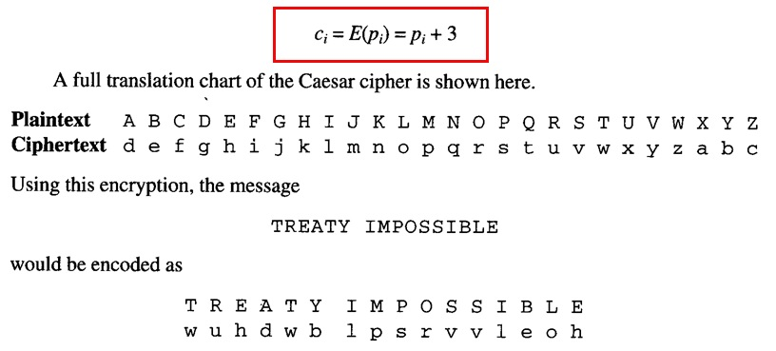

Q3. Design a TIC TAC TOE game. Use structures to get the name and age of users and the history of the games played must be stored in files.

**Note: Write the code neat, clean and as concise as possible.**